# Brazil’s Seven-Step NFe Electronic Invoicing Systems

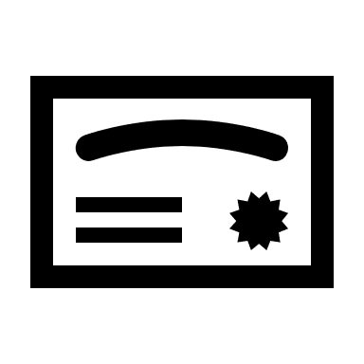

Digital signing certificate from Brazilian government



Supplier



Brazil Ministry of Finance

(Secretaria da Fazenda or SEFAZ)

Customs*

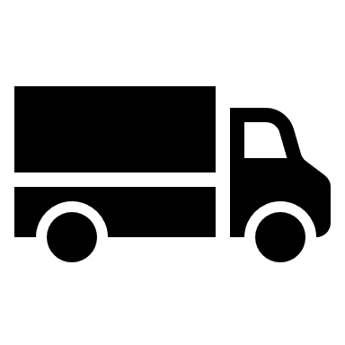

Carrier*



Buyer



➆

➀

➁

➂

➃

➄

➅

Signed XML submitted for approval

Validation check

Reception of Goods Confirmation

Retrieve NFe

Figure . Brazil's 7-Step NFe process.

SEFAZ official NFe

* Customs and Carrier steps ③, ④, and ⑤ and related processes do not occur with purchase and receipt of goods at point-of-sale. In this case, steps ①, ②, and (optionally to the Buyer) ⑥ always occur.

Figure 1 shows the 7-step process supported by the Nota Fiscal Eletrônica (NFe) electronic invoicing system in Brazil. This focuses on physical goods; however, services are also supported (see the **Additional Information** section below). Every document in the process is archived, logged, and available via a web portal and web services for validation, checking for discrepancies, and investigations undertaken by government officials.

1. Supplier registers with the government for a digital signing certificate. Once approved, the government provides the Supplier with the digital certificate, a private key that can be used as a signature on electronic documents. The Supplier produces an approved XML document from their ERP system and signs the XML invoice with their private key. Validation checks ensure that the XML contains the information required by the Secretaria da Fazenda (SEFAZ). The digitally signed XML is then sent to the SEFAZ via a third party service or via direct integration.
2. The SEFAZ receives the signed XML invoice, validates the private key and other information in real time and posts it back as an official NFe, which is stored in the Supplier’s ERP system prior to the release of goods to a Carrier. The SEFAZ evaluates Supplier master data and XML-invoice data in various ways to detect suspicious patterns of tax evasion or other compliance problems.
3. The Supplier prints out the physical representation of the NFe (a PDF file). This PDF is called a DANFe (Digitally Authorized Nota Fiscal Eletrônica) which is a printable representation, with bar codes embedded, that must be placed on the truck with the shipment. The DANFe/NFe may also be sent to the Buyer via electronic means such as email; however, direct communications using web services, FTP/s, and portals are also common.
4. The Supplier releases the truck for delivery. At any time after the shipment departs from the Supplier, a government official including Customs agents and patrolling police have real-time access to validate the shipment by scanning the DANFe bar codes. If the physical goods in the shipment don’t match those in the official NFe produced by SEFAZ, the truck can be impounded and will not be released until financial penalties are paid.
5. Buyer receives and checks the goods at unloading.
6. The Buyer must validate the NFe with the SEFAZ. The returned approval codes must be incorporated into the buyer's monthly accounting reports to the government. By forcing the buyer to validate, the government can ensure that the goods received by the Buyer match those sent by the Supplier as well as the prices and taxes.
7. Receipt of Goods Conformation closes out the process.

Validations and data analyses that occur in these steps are an important for providing a fair and equitable business environment by ensuring the correct taxes were paid, and eliminating tax leakage through fraud or other forms of non-compliance.

## Additional Information

**NFe for Physical Goods**: This is the document that organizations use. If the goods are being transported by a carrier, the truck cannot leave the warehouse until the purchase document (the XML transmitted to the Ministry of Finance) is approved, printed out and placed on the truck (the printed document, as opposed to the NFe, is called a DANFe). The 21 states in Brazil and a national web service endpoint (DPEC) provides the necessary interfaces between Suppliers, Carriers, and Buyers.

**NF-E-s for Services**: Services invoices are managed at the city level. The city of NFe-s issuance is the city a Supplier sells to, for example, if selling to the City of Sao Paolo, then Sao Paolo is the city of NFe-s issuance. A Supplier of services will send the invoice to the city, the city will apply the appropriate legislation, and a Buyer will pick up their invoices directly from the city websites.

**CTe** **Transportation Invoice**: Transportation invoices are for Suppliers using a 3rd-party logistics (3PL) or freight forwarder. Transportation invoices must be validated by the Buyer, posted in their purchasing system, and included in monthly reports sent to the government.